#Advanced Wordpress deployment  
  
[AWS how to setup VPC, Public, Private Subnet, NAT, Internet Gateway, Route Table? - (Part-5) (youtube.com)](https://www.youtube.com/watch?v=43tIX7901Gs)

Requirement   
A VPC with 3 public and private subnets  
MySQL RDS Database in private subnets  
Steup EC2 instance and wordpress inside private subnets  
and connect that EC2 to RDS using security groups  
and place an application load balancer in public subnets with target group as ec2 instance  
  
Let’s create a VPC.  
  


Within vpc we need to create public subnet as well as private subnet,

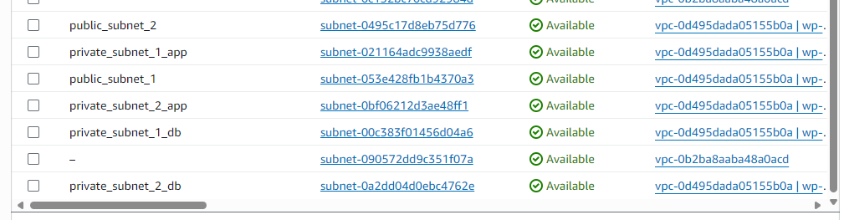  
  
Next, we will create route tables and associate it with respective public and private subnets (from above ss)  
  
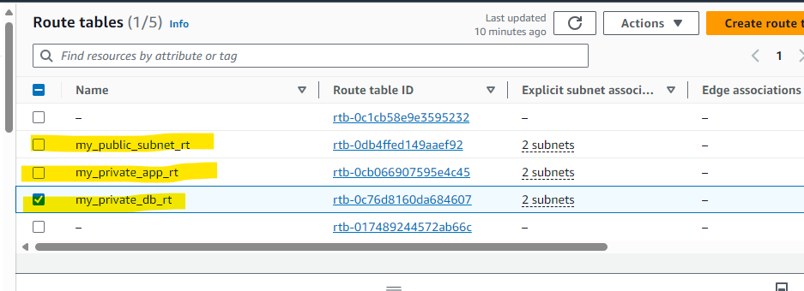  
  
Once routes are added, now we will create an internet gateway (IG) and attach it with our VPC

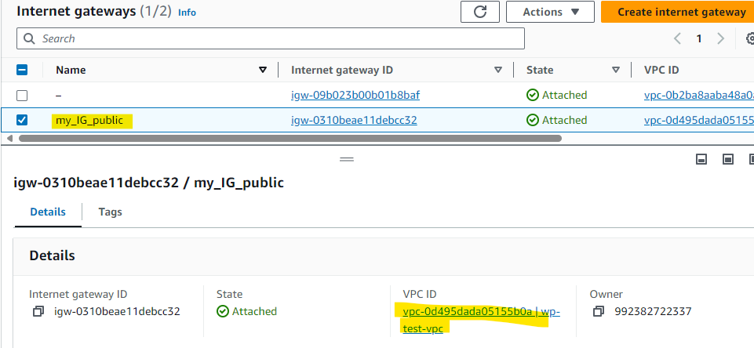

Finally we will create a NAT Gateway (placed under public subnet), will allocate elastic IP and NAT gateway will help private subnets to interact with internet.  
  
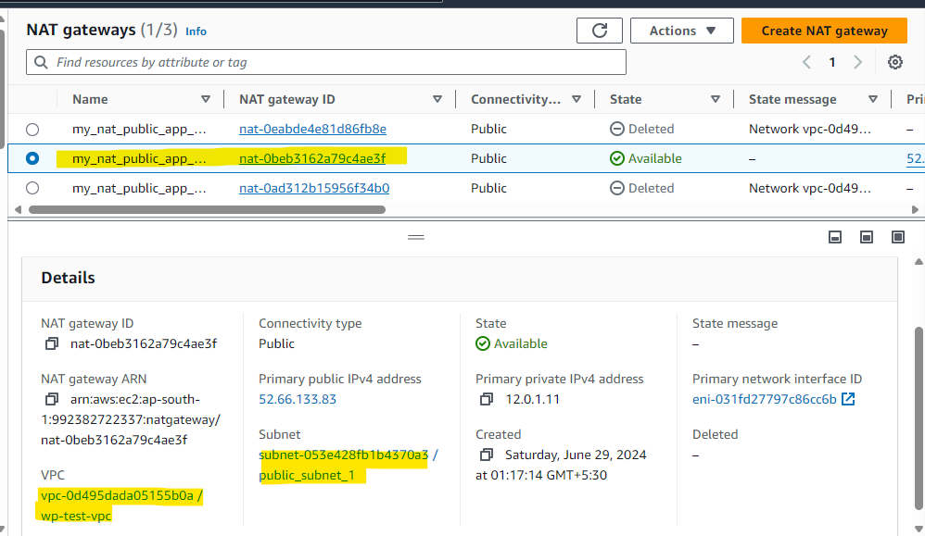  
  
Now, we will add IG and NAT into route table,

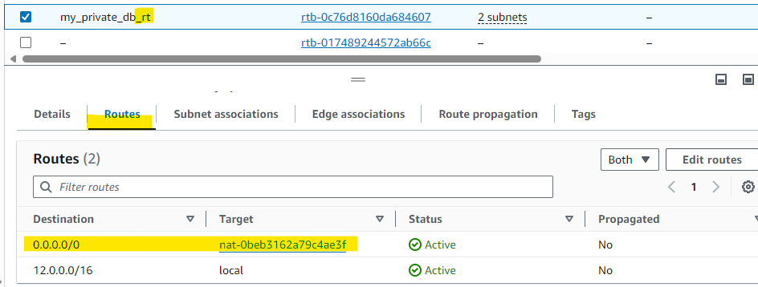

We are done with networking part. So, lets proceed with RDS database creation and application installation.  
  
Creating subnet groups for DB,   
  
Now will launch a RDS MySQL DB (within private subnets),  
  
Proceeding with launching an EC2 instance,

Once instance is launched will install apache2, install mysql server on instance and install wordpress on it. Use sudo before running the command

Before writing a script we should add below line  
#!/bin/bash  
  
**Note:** (We can edit user data scripts on running instance (but to get the changes affected we have to )  
  
Since we are launching application server on private subnet we can’t connect through ssh directly, instead we can try connecting with Jump server (launched on public subnet).

Login to Jump server and connecting our application server through ssh,   
  
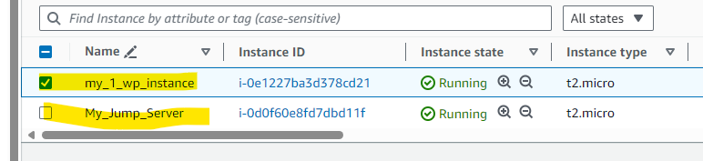  
  
As while creating instance we must download a key pair which helps us to do ssh to the instance (stored in local machine).   
Now we will ssh to our jump server from local machine and the directory were the key pair is present.

  
Moving to the below directory, we will create a keypair file with same content copied from base machine.

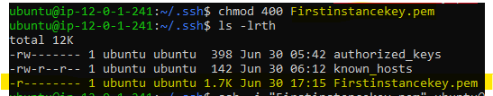  
  
Let’s connect our RDS MySQL with db endpoint,  
  


Once connected, lets create a DB under mysql

Now download wordpress cd /tmp  
wget https://wordpress.org/latest.tar.gz

next unzip (if installation is needed please install unzip first) tar -xvf latest.tar.gz

Move wordpress folder to apache document root sudo mv wordpress/ /var/www/html  
  
Next we will create an image of the first instance,  
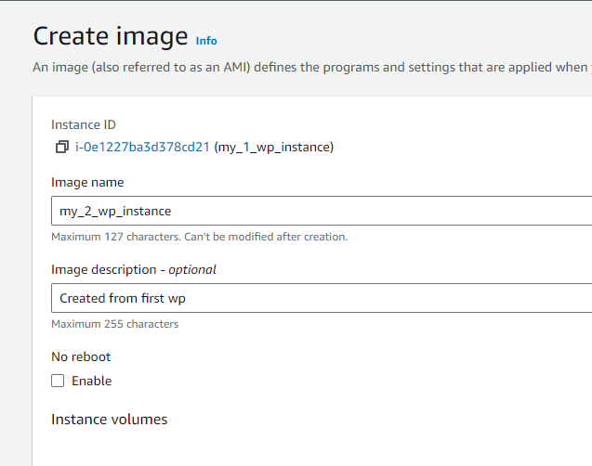  
  
Let’s Create ALB into public subnet (internet facing) and connect to both application instances with help of target groups (into private subnet).  
** Allow traffics from ALB into application instance  
** Allow traffics from application towards DB  
  
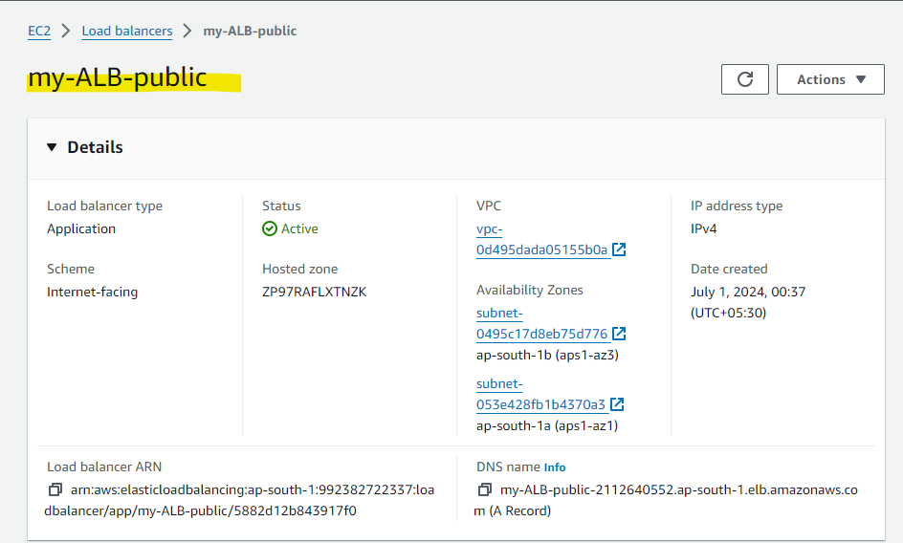  
  
  
  
  
Copy paste the DNS name into browser will lead to the web page as shown below,  
  
Now copy below configuration and write it under /worpress path with file name as wp-config.php  
  
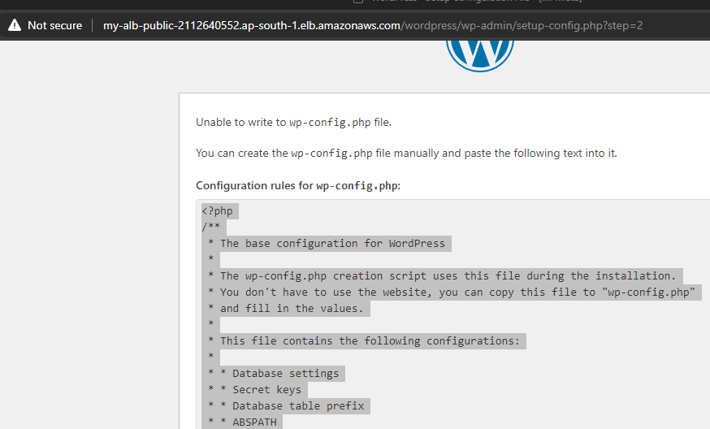  
  
  
Next we can click on installation

Successfully we have launched our wordpress site. 😊  
  
  
  
Created an html file to check the working of load balancer across instance.  
  
  
  
  
  
